Securing Data by Encrypting and Decrypting
Dr. Bhoomi Gupta, Tanya Gupta & Archit Gupta
Assistant Professor, Student
Maharaja Agrasen Institute of Technology, Delhi

Abstract: Information security is a major issue in this digital world. Need for encrypting and decrypting data have recently been increased in great demand and is widely investigated and developed because there is a demand for a stronger encryption and decryption which is very hard to crack. Cryptography plays major roles to fulfillment these demands. Nowadays, many of researchers have proposed many of encryption and decryption algorithms such as AES, DES, RSA, and others. But most of the proposed algorithms encountered some problems such as lack of robustness and significant amount of time added to packet delay to maintain the security on the communication channel between the terminals. This research paper focuses on a New Approach for Complex Encrypting and Decrypting Data which maintains the security on the communication channels by making it difficult for attacker to predicate a pattern as well as speed of the encryption / decryption scheme.
- Introduction
In network security, cryptography has a long history by provides a way to store sensitive information or transmit it across insecure networks (i.e. the Internet) so that it cannot be read by anyone except the intended recipient, where the cryptosystem is a set of algorithms combined with keys to convert the original message (Plain-text) to encrypted message (Cipher-text) and convert it back in the intended recipient side to the original message (Plain-text) ^{[1]}. The first model proposed by Shannon on the cryptosystem is shown in figure 1 ^{[2]}.
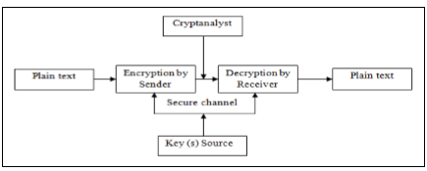Figure 1. Shannon model of secret communication
In computer systems, the algorithm consist of complex mathematical formulas that dictate the rules of conversion process from plain text to cipher text and vice versa combined with the key. However, some of encryption and decryption algorithms use the same key (i.e. sender, and receiver). And in other encryption and decryption algorithms they use different keys but these keys must be related.
The major issue to design any encryption and decryption algorithm is to improve the security level. Therefore, this paper aims to propose a new algorithm to improve the security level and increase the performance by minimizing a significant amount of delay time to maintain the security and makes comparative study ^{[4]}. This paper is structured as follows: comparison between the most popular encryption algorithms, Advanced Encryption Standard (AES), Public Key Infrastructure (PKI), proposed technique, performance analysis, security analysis, and conclusion.
  - Comparisons of Most Popular Encryption Algorithms
There is quite a number of encryption algorithms used for keeping information secured. Their complexity and ability to resist attack varies from one algorithm to another. The main component of encryption process is the algorithms that serve basic purpose in different ways. Popularly used algorithms include DES, TripleDES, RC2, RC4, Blowfish, Twofish and Rijndael (AES) as we mentioned in the abstract. The basic information of the most popular ciphers is shown in table1^{[5]}.It has several advantages like, it is flexible because of ability to pick and choose various modules, it has enhanced security and has strong user-community support.^{[7]}
Table 1. Comparison of popular encryption algorithms
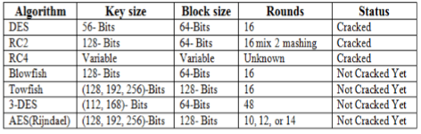

  - Advanced Encryption Standard (AES)
Based on the table 1, the National Institute of Standards and Technology (NIST) in 1997, announced officially that Rijndael algorithm would become the Advanced Encryption Standard (AES) to replace the aging Data Encryption Standard (DES). AES algorithm is a block cipher text the block size can be 128, 192 or 256 bits. 128(AES -128), 192(AES -192) and 256 (AES -256) bits key lengths ^{[5- 7]}.
The Rijndael algorithm is based on round function, and different combinations of the algorithm are structured by repeating these round function different times. Each round function contains uniform and parallel four steps, byte substitution, row shifting, column mixing 147 and key addition, the data is passed through Nr rounds (10, 12, and 14), and each step has its own particular functionality as shown in figure 2 ^{[7]}.
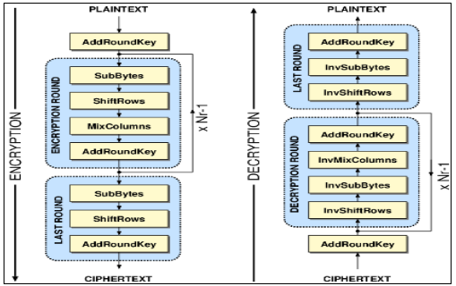 Figure 2. Advanced encryption standard structure
  - Public Key Infrastructure (PKI)
PKI provides series of security services such as, authentication, confidentiality, non-repudiation, and integrity to the messages being exchanged ^{[8- 10]}. In this paper, PKI use in connection establishment phase to exchange the security value between the network terminals i.e sender, and receiver.
- PROPOSED TECHNIQUE
The proposed algorithm is an attempt to present a new approach for complex encrypting and decrypting data based on parallel programming in such a way that the new approach can make use of multiple-core processor to achieve higher speed with higher level of security.

  - Encryption
In term of encryption process, the algorithm consists of combination of public key infrastructure for hybrid system and RC6 algorithm for confusion and diffusion operations.
Public position is Hexadecimal numbers arranged in 8*8 matrix announced to all. In this step RC6 algorithm play major roles to generate a private position based to the secrete value from public key infrastructure. Plain-text 1024- bits size divided to 2 blocks. One of these blocks used as key after performed confusion and diffusion operations using RC6 algorithm. The last step is Insert the key inside the Cipher data based on the private position.
  - Decryption
The decryption process involves converting the encrypted data back to its original form for the receiver’s understanding. The same process is performed at the beginning of the encryption and decryption process (connection established) as described in the encryption part at the sender side to generate the same private position at the receiver side to eliminate the key from the cipher text.
- SECURITY ANAYSIS
In order to test the security level of the proposed algorithm, a set of tests and analysis are performed on the algorithm. Some of these tests are taken from different cryptanalysis papers, NIST statistical suite, and combination of several other statistical analyses. The following analysis methods are performed on the algorithm: Information Entropy^{[11]}, correlation analysis between the public and private positions ^{[12-13].}
  - Correlation Analysis
As we mentioned in section 2.1, RC6 algorithm play major roles to generate a private position based to the secrete value from public key infrastructure. To analyze the correlations between the public and the private positions, correlation coefficients test is used. The correlation coefficients rules are described by a pseudo-code shown in figure 3 ^{[11, 13].}
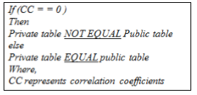
Figure 3. Rules of correlation coefficients
In correlation analysis, we randomly choose different values in the public and private positions (8*8 matrix). The correlation coefficients of the public and the private positions in vertical, horizontal, and diagonal directions were calculated. The correlation coefficients for the three dimensions in the private positions are close to zero, and for public positions are close to one. This indicates that the public and private positions are not correlated.
  - Information Entropy
To calculate the entropy H(X), we have:
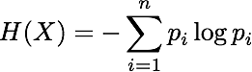
The entropy value H (X) for the proposed algorithm is 7.98789 which is very close to the theoretical value 8. This indicates that the encryption algorithm is secure upon the entropy attack.
  - The Strength of Encryption
The strength of encryption measure by the time required to decode or extract the key ^{[10]}. The calculation of encryption strength of an encryption algorithm the following equation is used ^{[14]}.
Differential Characteristic = (p1p2) −1 ×Filtering weight. The result shows, the proposed algorithm needed 1.00E+68 time (Years) to crack.
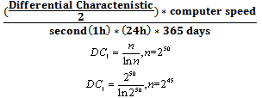
- Conclusion
This paper introduced a new approach for complex encrypting and decrypting data. Although there have been many researchers on the cryptography, but most of the existing algorithms have several weaknesses either caused by low security level or increase the delay time due the design of the algorithm itself. The proposed algorithm have been tested against different known attacks and proved to be secure against them. Therefore, it can be consider as a good alternative to some applications because of the high level of security and average time needed to encrypt and decrypt a data using a proposed algorithm is much smaller than AES algorithm.

References
[1] P. Zimmerman, "An Introduction to Cryptography", Doubleday & Company, Inc., United State of America, USA, 1999.
[2] C. Shannon, “Communication Theory of Secrecy Systems”, Bell Systems Technical Journal, MD Computing, vol. 15, pp. 57-64, 1998.
[3] I. Nichols, K. Randall (1999), ICSA Guide to Cryptography, McGraw-Hill, Companies Inc, New York.
[4] H. Mohan, and R. Raji. "Performance Analysis of AES and MARS Encryption Algorithms". International Journal of Computer Science Issues (IJCSI), Vol. 8, issue 4. 2011.
[5] A. Lee, NIST Special Publication 800-21, Guideline for Implementing Cryptography in the Federal Government, National Institute of Standards and Technology, November 1999.
[6] J. Nechvatal, Report on the Development of the Advanced Encryption Standard (AES), National Institute of Standards and Technology, October 2, 2000.
[7] M. Wali and M. Rehan, “Effective Coding and Performance Evaluation of the Rijndael Algorithm (AES)”, in the Proceedings of the Engineering Sciences and Technology Conference, vol. 7, pp. 1-7, Karachi, 2005.
[8] C. Jie, “Design Alternatives and Implementation of PKI Functionality for VoIP”, Master of Science dissertation, Telecommunication Systems Laboratory, Royal Institute of Technology (KTH), Stockholm, 2006.
[9] R. Hunt, “PKI and Digital Certification Infrastructure”, in the Proceedings Ninth IEEE International Conference on Networks, vol. 4, pp. 234 – 239, Bangkok, Thailand, 2001.
[10] S. Xenitellis, The Open–Source PKI Book: A Guide to PKIs and Open-Source Implementations, Open CA Team, 2000.
[11] S. Tao, W. Ruli, and Y. Yixun, “Clock-Controlled Chaotic Key-Stream Generators”, Institution of Engineering and Technology Electronics Letters, vol. 34, pp. 1932-1934, 1998.
[12]A. Masoun, ”Cryptography Primitives Based on Piecewise Nonlinear Chaotic Maps”, Master of Science dissertation, Universiti Sains Malaysia (USM), Pineng, Malaysia, 2008.
[13] Obaida. Al-Hazaimeh, " Increase the Security Level for Real-Time Application Using New Key Management Solution", International Journal of Computer Science Issues(IJCSI), Vol. 9, Issue 3, 2012.
[14] L. Chang-Doo, C. Bong-Jun, P. Kyoo- Seok (2004), “Design and evaluation of a block encryption Algorithm using dynamic-key mechanism”, Future Generation Computer Systems 20, 327–338.

